

Functional Specification Documentation

For
e-Statement of Account

Version No.: 1.0
Date: 13th December 2016

Table of Content
1. Overview Details 2

1. Overview Details
User to select statement send to customer by batch instead of print to pdf and email separate one by one which is time consuming.

SOA Format:
SOA email will be in line and PDF. User has to choose which format to send. / or choose all. ** report format follow Exedy Customer Statement of Account.

SOA Method: by MAIL / by EMAIL
This will be defined in Business Partner master data.
Send only if the method = by EMAIL

SOA to have a column called Email for SOA.

Query for new customer with column Email for SOA, SOA method.

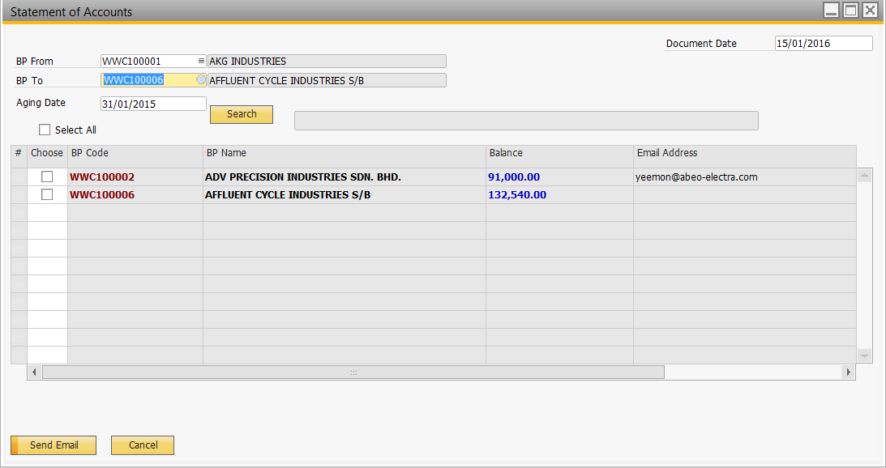
Click to choose either or all
In Line
PDF
To have a remark column let user to key in and the input will be reflected in the email.
Choose SOA Method

SOA Format
Print

Email ID configuration:

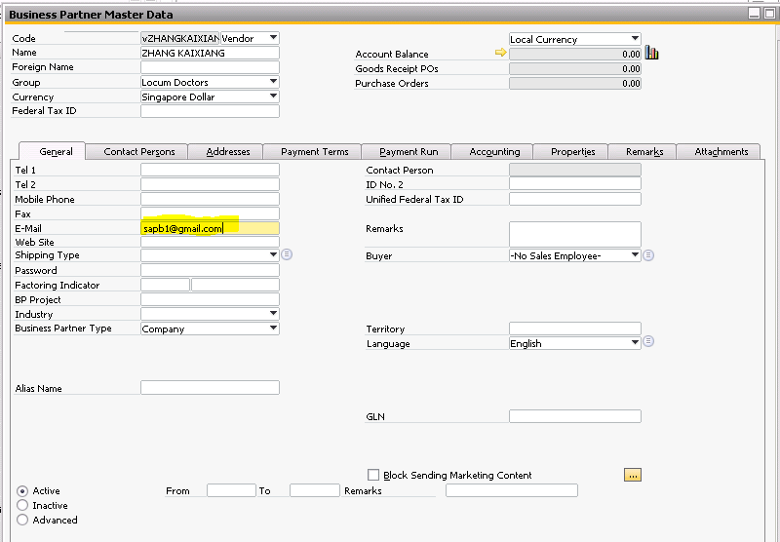
3. Send to general email.

Sample UI:

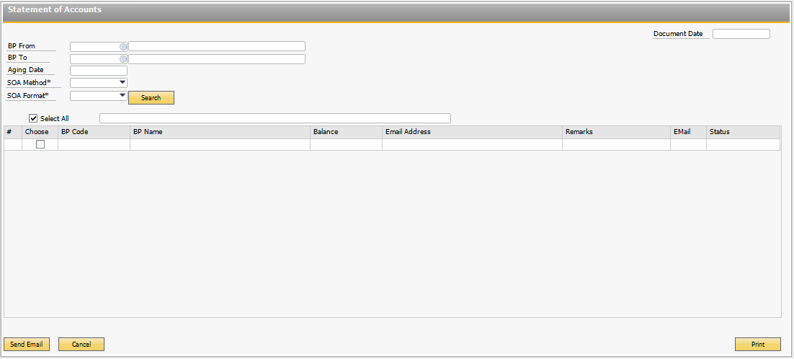
# | Field Name | Description | Remarks
1 | Customer Code | User will select Customer Code “From” and “To”.
2 | Customer Name | Auto populate once the user selected the customer.
3 | Aging Date | Accumulated balance as per the selected date by user.
4 | SOA Method | by MAIL / by EMAIL
5 | SOA Format | In Line / PDF

